Vasectomy/Reversal

We are experts in No-Scalpel Vasectomy and Vasectomy Reversals. The No-Scalpel Vasectomy is a technique that results in less pain and fewer postoperative complications. A vasectomy is considered to be a permanent birth control procedure, even though these operations can be reversed as life circumstances may change. If reversed, you can expect a subsequent pregnancy rate of approximately 60 - 80% if done within five years of the sterilization.
Vasectomy:
Vasectomy is a minor surgical procedure that can be performed in the doctor’s office or hospital under local anesthetic and involves cutting the vas deferens in the scrotum. The surgery takes approximately 15 minutes and involves making 1-2 small incisions on each side of the scrotum. The sperm duct (vas deferens) is then cut and sealed, and the sealed ends of the duct are returned to the scrotum. To reduce the possibility that the cut tubes may rejoin, a ½- to 1-inch piece of vas deferens may be removed during the surgery. The skin incisions are so small that stiches may not be used. If the stitches are used, they will dissolve by themselves.
Surgical Vasectomy
Before Vasectomy After Vasectomy
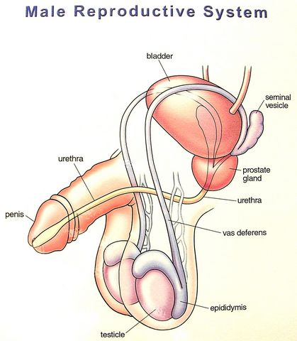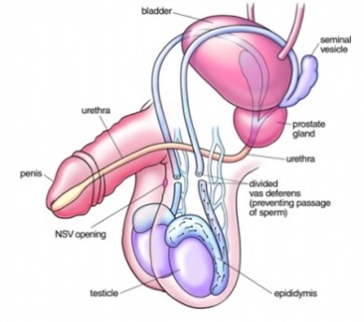

Description of the Attendant Discomforts and Risks:
A small amount of oozing blood (enough to stain the dressing), some discomfort and mild swelling in the area of incision are not unusual and should subside within 72 hours.
Occasionally, the skin of the scrotum and base of the penis turn black and blue. This is not painful, lasts only a few days, and disappears without treatment.
Very rarely, a small blood vessel may escape into the scrotum and continue to bleed to form a clot. A small clot will be absorbed after a time, but a large one is painful and usually requires reopening of the scrotum and drainage. Hospitalization and a general anesthetic may be required for this purpose.
For 1 week following the vasectomy, sex should be eliminated. Strenuous exercise (for example, climbing ladders, riding motorbikes or bicycles, playing tennis, etc.) should likewise be avoided for 3 days, and nothing that weighs over a few pounds should be lifted. The reason for this is that engaging in these activities sometimes results in complications.
The surgical procedure is not always 100% effective in preventing pregnancy, because on rare occasions the cut ends of the cord may rejoin. This only occurs at a rate of 1 in every 2,000 vasectomies. Sperm can survive from the point where the cords were cut for months, so another form of contraceptive must be used until sterility is assured. For this purpose, a specimen of seminal fluid should be brought in for microscopic examination. The specimen must contain no sperm before unprotected intercourse is allowed. Occasionally, it may take 6 months or longer to flush out all the sperm.

Benefits to be Expected:
The vasectomy is done in our office in approximately 30 minutes using a local anesthetic; it is a simple, safe method to prevent unwanted pregnancy. Recovery is quick, and the patient can usually return to work in 2 days (over a weekend).
Sexual activity, penile sensitivity, and the production of the male hormones are not adversely affected. In fact, the freedom from fear of producing unwanted children may greatly improve the mutual enjoyment in your sexual relations. You may find that your desire for sexual expression becomes more spontaneous and more frequent.

Counseling Concerning Alternate Methods:
If your objective is merely to space pregnancies, or if you have the slightest reason to believe that you might want to have children in the future, then a vasectomy will not suit your purpose and should not be considered.

Other methods of birth control that may be used are:
• Oral contraceptive (the pill) • Aerosol contraceptive foam
• Intrauterine device (IUD) • Rhythm
• Diaphragm • Contraceptive cream and jellies
• Condom • Abortion
If you should decide that vasectomy is not for you, yet you and your wife are sure you do not want to have children or more children, a tubal ligation for your wife is an alternative method. This is likewise a permanent method of birth control.
A vasectomy should have no adverse effects on our sex life. Any problems that develop in relation to having sexual intercourse would result from psychological rather than physical causes. After a vasectomy, a man’s hormones remain normal, and there is not noticeable difference in his ejaculate, since sperm make up only a tiny part of the semen. Because the sperm cannot come out after the cord is cut, like other dead body cells, the sperm disintegrate and are reabsorbed by the body.
Some men, even knowing these facts, are still anxious about what a vasectomy will do to their sexual performances. These men should not have vasectomies. Worrying about sexual performances is likely to impair a man’s ability to have an erection or ejaculate, even though the production of sperm and male hormones continues.
A vasectomy is not the answer to a problem of sexual maladjustment or failing sexual performance. Therefore, if you are getting a vasectomy in hopes of improving your wife’s attitude toward sex or increase your sexual function, you are likely to be disappointed. On the other hand, the freedom from fear of producing unwanted children may improve greatly the mutual enjoyment in your sexual relations.

Effect and Impact of Sterilization:
The purpose of a vasectomy is to prevent sperm from entering the seminal fluid so that the female egg cannot be fertilized subsequently to intercourse. Sperm cells continue to be produced in the testes but disintegrate and are reabsorbed. However, the amount of fluid discharged during intercourse does not decrease more than 5% after vasectomy.
A vasectomy is considered to be a permanent birth control procedure, even though these operations can be reversed if absolutely necessary, with a subsequent pregnancy rate of approximately 60% if reversal is within 5 years of the sterilization. Although a vasectomy must be thought of as producing permanent sterilization, the procedure is not always 100% effective.

Vasectomy and Long-Term Health Problems:
Vasectomy began to be a popular means of permanent sterilization in the 1950s and 1960s. While isolated studies have caused concern from time to time regarding general health hazards that might be associated with elective vasectomy, no real problems have ever been identified.
It is true that after vasectomy approximately 60%-70% of men develop antisperm antibodies in their blood and, in effect, this is a type of allergy to one’s own sperm proteins. However, it has never been shown conclusively that these antibodies have any significant effect on any other organ.

Vasectomy Reversal:
Why choose Dr. Tariq Hakky?
As a Urologist and Microsurgeon, Dr. Hakky specializes in the treatment of disorders of male infertility and sexual dysfunction. Dr. Hakky completed his Urology residency at the University of South Florida in Tampa. During his tenure as a resident he created an online patient database, wrote 5 IRBs, obtained two patents, presented posters, podiums, and Andrology videos both in the United States and internationally. He also attended and assisted with over 5 prosthetic training programs and has published over 50 Urology/Andrology related articles/videos. He then completed a fellowship in Male Reproductive Medicine and Surgery at Baylor College of Medicine. His clinical practice uses only the latest microsurgical equipment, and he has performed many vasovasostomy and epididymo-vasostomy procedures.

How long is the procedure?
Operating time for a vasovasostomy or epididy-movasostomy is approximately 2-3 hours. A general anesthetic usually is used, but a regional anesthetic (spinal or epidural) can be selected. We prefer that out-of-town patients stay in Atlanta for at least 1 day after surgery.

How long is the follow-up period?
Postoperative follow-up includes an evaluation of wound healing at 2-3 weeks and a semen analysis at 6-8 weeks. Monthly semen analyses are then obtained for approximately 4-6 months, or until results of the semen analysis stabilizes. If you do not live in Atlanta, we will assist you in finding a physician and laboratory near your home with whom we can communicate for postoperative evaluations.

What is your success rate?
The success of a vasectomy reversal depends on a combination of:

1. The skill of the surgeon.
2. The findings at the time of surgery.
When the vas is opened, fluid will flow from the testicular side of the vasectomy site. If sperm are present, a vasovasostomy will be performed. We expect 95% or more of these patients to demonstrate a return of sperm to the ejaculate, with an associated 60%-70% pregnancy rate. If no sperm are present, but the vasectomy fluid appears to be abundant and ultimately suitable for sperm production (e.g., clear, watery), then a direct vasovasostomy is performed, with the expectation of a successful outcome such as that described above.
If poor-quality fluid is present (e.g., thick, pasty) and sperm are absent, or no fluid at all is found, then an epididy-movasostomy (connection of the vas to the epididymis) is performed, with return of sperm to the ejaculate in 65% of our patients.

Vasectomy Reversals: TECHNICAL details about the surgery.

Microscopic Vasovasostomy (VV) and Epididymo-vasostomy (EV) – More Information:

A vasectomy reversal (VV or EV) is an operation that reestablishes a connection between the two ends of the vas deferens that were separated at the time of an earlier vasectomy. Sometimes during the microsurgical reversal, the vas deferens must be reconnected to the epididymis (epididymo-vasostomy) because of a secondary obstruction in the epididymis. Both procedures are performed entirely under a special operating microscope.
Sperm production takes place in the testis. After passage through the efferent ducts, sperm are stored and undergo maturation within the epididymis, a coiled microscopic tube that runs from the testis to the vas deferens. The vas deferens is responsible for directing and propelling the sperm into the urethra.
Increasing numbers of men are coming to the urologist for vasectomy reversals, most commonly because of remarriage and the desire to initiate a pregnancy. Vasectomy reversals are also requested by couples who have merely “changed their minds,” as well as by couples who have lost a child and are attempting to initiate another pregnancy. Fortunately, microsurgical advances are now resulting in significantly improved pregnancy rates.
The surgeon you choose should be skillful with microsurgical technique, as precise suture placement is critical to the success of the procedure. The surgeon must also have the ability to perform the more difficult epididymo-vasostomy procedure as well as a vasovasostomy (see diagram).

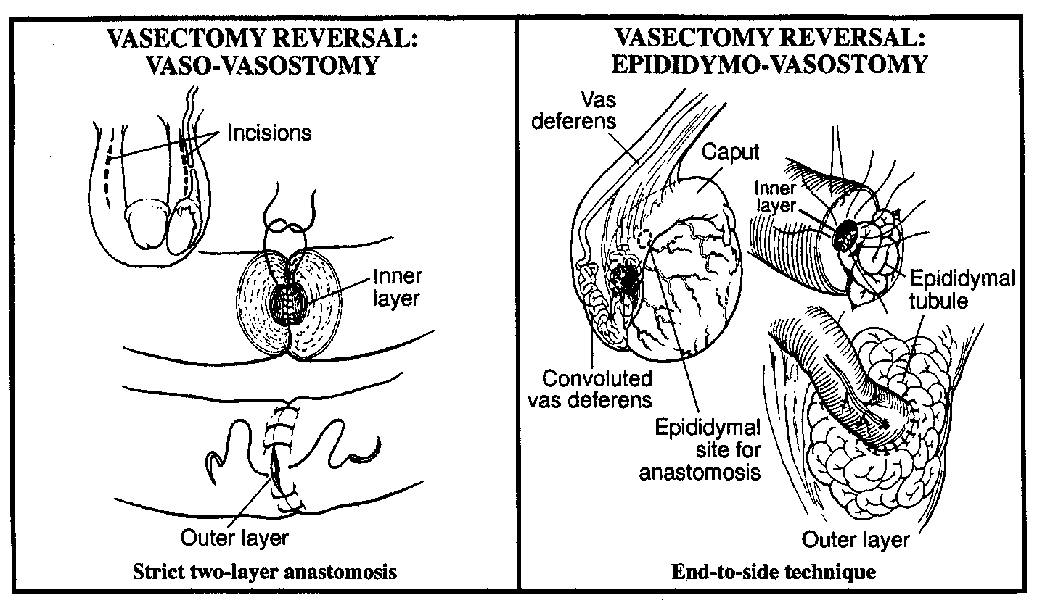

Dr. Hakky uses a two-layer suture technique, utilizing microscopic sutures and the latest microsurgical equipment. He performs approximately three of these procedures weekly on an outpatient basis. This arrangement allows patients to return home or to a nearby hotel without actually being admitted directly to the hospital, thus saving considerable expense and making the overall experience much more pleasant. The surgery is performed in the day surgery unit at Advanced Urology. This facility feature state-of-the-art microsurgical equipment and a hospital staff well trained to assist in these procedures.
Cryopreservation of sperm (sperm banking) is routinely offered at the time of vasectomy reversal if whole, motile sperm are present. Cryopreservation is performed as a safety “backup” in case adequate sperm counts are not achieved after surgery. Because vasectomy reversals may infrequently scar, despite good initial results, cryopreservation may also be performed on ejaculated specimens early in the course of recovery when semen quality is exceptionally good.

Videos:
Vasectomy Reversal - Vasovasostomy
https://www.youtube.com/watch?v=_oH-qMZ9P2A

Epididymo-Vasostomy Two Suture Technique
https://www.youtube.com/watch?v=KfdHGTkX5Rk

