Penile Implant Surgery

A penile implant is a device that can help a man achieve and sustain an erection. When other treatments have been unsuccessful, you may be a good candidate for this minimally invasive procedure. Dr. Hakky is an international expert in this field and has helped thousands of men regain their sexual function, self-confidence, and quality of life. Penile implants offer many advantages such as:
- Patient Satisfaction: Over 93.8% of patients report satisfaction, far outpacing satisfaction levels for Viagra (51.6%) or injection therapy (40.9%).
- Natural Appearance: Achieve and maintain a natural looking erection at any time with normal sensation.
- Minimal Recovery Time: Following the minimally invasive outpatient procedure, a short four to six-week recovery period is all that is needed before the implant can be used.
- Insurance Coverage: Most insurance, including Medicare, cover the implant.

There are two different types of penile implants available, the Coloplast Titan Touch® inflatable implant and The Genesis® flexible implant. Both enable men to have a satisfactory erection for intercourse. The main difference is that the Genesis® is permanently firm, whereas the Titan® can be inflated and deflated for a more natural look.

The Titan Touch® Inflatable Penile Implant

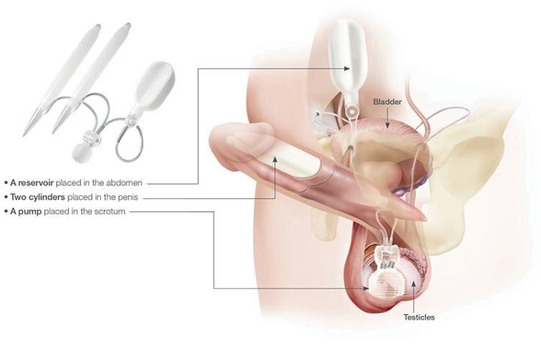
Titan Animation Video

The Coloplast Titan Touch inflatable penile implant is a self-contained, fluid-filled system made from Bioflex and silicone. Titan penile implant is designed to mimic the look and performance of a natural erection.
Its unique features include:
- Maximized Girth and Rigidity – Coloplast implants provide greater girth and rigidity compared to other cylinders on the market. Sizes range from 11 cm to 28 cm.
- Natural Appearance – Designed to emulate the look and performance of a natural erection.
- Ease of Use – Titan Touch pump is easy to locate, inflate and deflate.
- One-Touch Pump – Titan Touch is the only penile implant pump with a true one-touch release. It only requires a momentary compression of the deflation button to allow a complete fluid transfer out of the cylinders.
- Innovative Cloverleaf Reservoir Design – Only penile implant featuring a Lock-out™ value on the reservoir to help prevent against the 2% need of surgical revisions due to auto inflation.
- Lifetime Replacement Policy – Coloplast provides a lifetime replacement policy with all of its penile implants. The inflatable implant, or any component, can be replaced due to device malfunction.

The Genesis® Flexible Rod Penile Implant

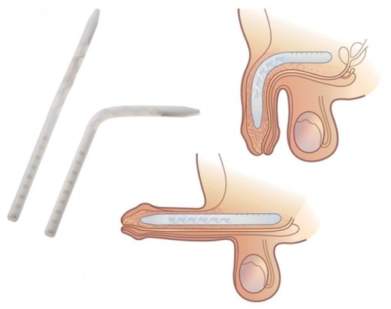

The Genesis® is a flexible penile implant that consists of two firm but flexible rods that are placed into the shaft of the penis. There are no other parts to this implant. To have an erection, you simply hold the penis and move it into the desired position. When you are finished, you bend it back down to conceal it. The malleable penile implant can be a good option for men with limited dexterity.

FAQs

Will I lose any length after getting a penile implant?
Each penile implant is custom fit to your anatomy. Discuss this in greater detail with your physician.

Will I be able to have spontaneous erections with a penile prosthesis?
Both the Titan and the Genesis give you the ability to have an erection instantly and spontaneously, any time you want one. 31 32 However, the implant surgery makes it impossible to ever have a “latent” or natural erection that’s not dependent on the device. Therefore, you should consider carefully whether or not an implant is the right choice for you.

What is the recovery time?
Each individual is different and therefore their recovery will be different as well. Typical recovery is between 4-6 weeks. Your physician will determine what you can and cannot do during this time. It is important to follow the recommendations that your physician gives to you to ensure the best outcome.6

Is the cost of a penile implant covered by insurance?
A penile implant is prescribed by your physician. Most insurance, including Medicare, covers the implant. Check with your physician’s office and your insurance carrier to determine your actual cost.

What makes the Genesis® and Titan® Touch different?
Both implants provide you with the capability of having an erection satisfactory for intercourse. The main difference is that the Genesis penile implant is a malleable implant consisting of two rods that are placed in the corpora cavernosa. There are no further parts to this implant. To have an erection, you only need to hold the penis and move it into the desired position. When you are finished you return the penis to the previous position. With the Titan penile implant, you inflate the cylinders by pressing the pump bulb in the scrotum. You can control the firmness by pumping until you are satisfied with the erection. The best thing is to discuss each implant with your physician to make sure that you are getting the implant that is appropriate for you.

Are there risks associated with the penile prosthesis?
As with any surgery, there are some risks associated with the penile implant procedure including pain, anesthesia reactions, repeat surgery due to infections, or mechanical problems with the device. Discuss this in greater detail with your physician.

Will anyone notice that I have an implant?
The implant is completely placed inside your body. The Titan® inflatable penile implant is not visibly noticeable. The penis appears relaxed and normal when in the flaccid state, and it is not obvious by looking at a man that he has an implant.9 The Genesis® flexible rod implant stays firm when not in the erect position, and it may “show” through clothes.

Can I have an orgasm with a penile implant?
You should be able to have an orgasm with a penile implant if you were able to have one before your procedure. Consult your physician about your expected outcome.33

Can I still have an MRI with an implant?
Yes, the device is MRI conditional. A letter attesting to MRI conditions are available. Please click the "about Coloplast" link on the bottom and fill out the contact form to request that one to be sent to you.

