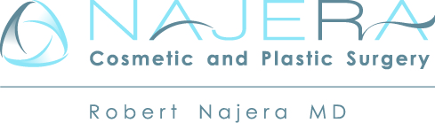

Permission to Use Photograph/Video

I, ____________________________, give my informed and voluntary consent to Texas Elite Plastic Surgery and/or his associates to take photographs and/or video of me pre-operatively, intra-operatively, and post-operatively. I understand that these photographs and/or videos will be utilized and posted on social media, advertising, and web content to show the transformation process to the general public which includes current and prospective patients. All pictures will remain anonymous and any identifying features will be blurred out as best as possible, however, I also understand that in some rare circumstances the photographs and/or videos may display features that identify me.
I understand entirely that this authorization is completely voluntary. I understand that any disclosure of information has the potential of unauthorized disclosure and the information may not be protected by applicable federal and/or state confidentiality rules. Dr. Robert Najera or a representative cannot guarantee, nor have liability should you disclose any identifying factors to a third party as they may not be required to maintain your privacy.
By signing this consent, I hereby, knowingly and voluntarily authorize Robert Najera, M.D., to use my photograph(s) and videos in the manner described above.

Signature _____________________________________________

Printed name __________________________________________

Date _________________________________________________

Signature, parent or guardian _____________________________
(If under age 18)
Witness: ______________________________________________

