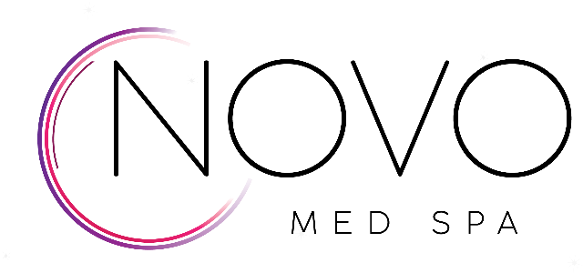

Consultation Intake Form

Please indicate the services and areas of interest

Uneven Skin Color Wrinkles Leathery Texture
Sun Damage Lip Lines Acne Scarring
Age Spots Crow’s Feet Large Pores
Melasma Fine Lines Hair Removal
Freckles Deep Lines Dry/Rough Skin
Broken Capillaries Frown Lines Alopecia
Rosacea Smile Lines Hair Loss
Acne Cheek Volume Skin Tightening
Facial Veins Chin Fat Tattoo Removal
Leg Veins Lip Enhancement Cosmetic Tattoo Removal
Redness Fine Facial Hairs
Vaginal Dryness
Incontinence
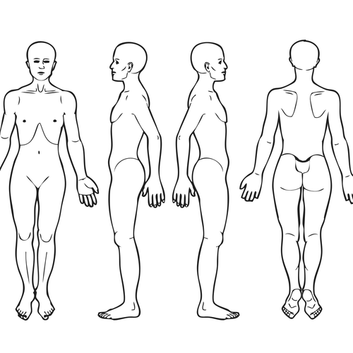
Circle any area(s) of concern for Body Contouring / Permanent Fat Reduction
Please list any other services you might be interested in ______________________________________________________________________________________________________________________________________________________________________________________________

