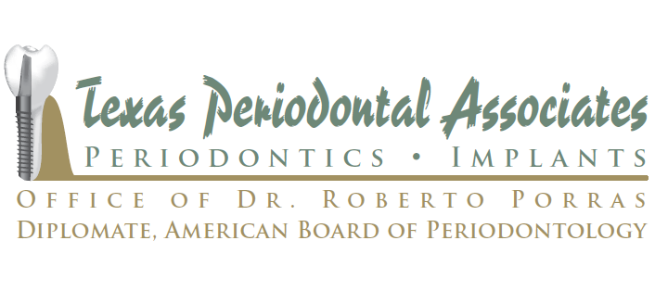

ROUTINE POST-SURGICAL INSTRUCTIONS

- MEDICATIONS/PRESCRIPTIONS: If any antibiotic is prescribed, it is to be taken until finished. Pain medication is to be taken as instructed on the bottle. The local anesthetic will wear off within 1/2 an hour to 3 hours following surgery. It is important to take your pain medication prior to discomfort. It is also important to eat prior to taking your pain medication. Not eating can cause nausea and vomiting. After the first 24-72 hours you may switch to using over the counter pain medications. If you should develop a rash itching, difficulty breathing, wheezing, nasal congestion or swelling around the eyes not related to the surgery stop taking the medication and notify our office immediately. ATTENTION: All female patients utilizing birth control pills, please be advised that if the doctor prescribes the use of any antibiotic, an alternative form of birth control must be utilized during the period of time.
- BLEEDING: Gauze was placed over the surgical site so that it serves as a pressure bandage when you bite down. Usually, we recommend leaving it in place until the numbness from the local anesthetic wears off and brisk oozing does not occur when the gauze is removed. Replace the gauze hourly to control bleeding if necessary. Remove the gauze when eating or taking medications. A small amount of oozing is normal. Pink or blood-tinged saliva may be present for 24-48 hours. You may wish to cover your pillow with a towel to avoid staining. Rest with head elevated on 2 or more pillows for the first day. Excessive bleeding can be controlled by placing a moistened tea bad over the surgical site for one hour while applying pressure
- Eating: Cold, soft foods for the first 24 hours. Suggestions: Ice cream, Jell-O, pudding, yogurt, cottage cheese, milk shakes, applesauce. For the next four days, follow a soft diet ( eggs, mashed potatoes, pasta). Drink more fluids than you usually would. No alcoholic nor carbonated beverages for 4 days after surgery. This will not the time to lose weight; proper nutrition is necessary for healing.
- Swelling: Some swelling after surgery is normal; don't be alarmed. It takes 3 days for surgical swelling to reach a peak before subsiding. Ice packs are used to reduce swelling and produce a local numbness immediately after surgery. Ice packs should be applied during the first 24 hours after surgery. Plastic bags filled with crushed ice and wrapped in a damp towel or a commercial ice bag are convenient forms of application. Apply for 20 minutes- leave off for 10 minutes. After discontinuing ice, switch to moist heat( hot water bottle or warm wash cloth). If there was swelling from infection at the time of surgery, use moist heat instead of ice!
- Rinsing: Avoid rinsing, spitting, drinking though a straw and alcohol containing mouth washes for the first 24 hours as it may prematurely dissolves the blood clot. A gentle rinsing with warm salt water ( one- half teaspoon salt in large drinking glass) after meals and at bedtime is important after this period. After 72 hours a more vigorous rinsing is encouraged after meals and at bedtime for two weeks.
- Bruising: Bruising may be present to varying degree. It will subside over a period of 5 to 10 days.
- Smoking: We advise you not smoke at all during the first 72 hours after surgery. Smoking can increase pain and lead to poor healing. The longer you refrain from smoking the less chance you have of postoperative problems.
- Activity: Avoid excessive physical exertion and fatigue during the immediate postoperative period. Obtain adequate sleep.
- Tooth Brushing: NO BRUSHING THE DAY OF SURGERY. Brushing of the immediate surgical site should be discontinued for about 1 week after surgery to prevent disruption of the blood clot, healing tissues and/ or sutures. The remainder of the mouth may be brushing normally. When you resume brushing at the surgical site you may experience a small amount of bleeding or discomfort, but this is normal.
- SUTURES/DRESSING: A variety of sutures and dressing may have been used as a part of you treatment and you may feel them with your tongue. They will either dissolve on their own or be removed at the appropriate postoperative appointment.
POST IV ANESTHESIA INSTRUCTIONS
The Major effects of the intravenous drug will have worn off before you are allowed to leave our office. However, there can be residual effects lasting 6-12 hours and sometimes longer. During this time, you reflex time and judgment may be altered. Therefore, you are advised to not drive an automobile or operate machinery during the day of the anesthetic. During that same period should you experience lightheadedness, dizziness, etc., do not attempt to walk without assistance.
IMMEDIATE DENTURE INSTRUCTIONS
The denture that was placed in your mouth immediately after surgery will serve as a surgical bandage. Leave the denture in pace for 24 hours. If the denture is removed too early, the oral tissue may continue to swell, and you will not be able to replace the denture. After 24hours, remove as needed to clean or rinse your mouth. After the initial 24 hour period, it is important to keep the denture out at night to allow for adequate healing.

POSSIBLE CONDITIONS AFTER SURGERY
One or more of the following conditions may develop after your surgery. If so, please refer to this sheet. Call our office if you have and additional questions at 713-457-6351.
- ANTIBOTICS: May cause diarrhea or stomach upset. Eating active culture yogurt may help decrease the incidence by restoring normal gastrointestinal flora.
- FEVER: The normal, average oral temperature is 98.6◦F. Your temperature may rise slightly for a day or two after surgery and is usually of no concern. If you feel warm or sweaty, we recommend that you take and record your oral temperature during the morning and before retiring. A persistently raised temperature should be reported to our office. Drink plenty of fluids during this period, but not within the few minutes before taking your temperature.
- DRY SOCKET: This may occur 3-5 days after surgery, usually with lower third molar (wisdom teeth). it usually is characterized by an "earache-like" throbbing pain and a foul taste and odor as the result of loss of the blood clot in the tooth socket. Treatment is simple, involving irrigation and dressing placement to alleviate the discomfort.
- MUSCLE STIFFNESS: Tenderness and stiffness within the chewing muscles may develop during the postoperative period and should not alarm you. It is usually due to swelling in the area of the muscles and is best treated with moist heat therapy. It will slowly resolve over a 5-10 day period.
- IV JECTION SITE: The point where the needle entered the vein may develop a bluish color which will change to yellow and then to normal in a matter of days. There may be a slight tenderness to the area
- NAUSEA/VOMITING: Nausea following surgery is usually due to taking medications on an empty stomach. keep eating and take as few pain pills as possible. Sipping 7-up, ginger ale, or cola may help. Call our office if serve nausea or vomiting persists.
- NUMBNESS: As we explained prior to surgery, a partial numbness of your lips or tongue may be apparent when the local anesthesia wears off. Time will usually resolve and it is hard for you to perceive the change. Sensation of "burning,"" tingling, "or "electric shocks" in the numb area indicate that feeling is returning. Call any numbness to our attention at your first operative visit.
- SHARP BONEY EDGES: Small pieces of bone may work out of the surgical area as long as 5-6 weeks after surgery. This may resolve on its own over a period of a few weeks. if necessary, removal of bone spicules is a simple and routine process.
- SORE LIP/CHEEKS: The corners of your mouth may be dry and cracked after surgery. This is best treated by gently applying Vasline.

